

A project Report on

Online Shopping

By

Ashwini Khandare(B.E.)

**Batch:-** 2020-5072

**Center:-** Thane

### Under the Guidance of,



Technical trainer

# EduBridge

(School of Coding)

# INTRODUCTION:

This Project **Online Shopping** has been developed on **Java, JSP and MySQL**. The main purpose for developing this project is to sell any product through online order. In this project **Online Shopping in java** Customers can give order from any place and pay cash on Delivery. This project provides a lots of features to manage in very well manner.

Software Requirement:

|  |  |
| --- | --- |
| **Front end** | **Java, JSP, CSS** |
| **Back end** | MySQL |
| **Server** | apacheTomcat7.0V |
| **Ide** | Eclipse Ide for EE developers |
| **Browser** | Google chrome |
| **Operating system** | Windows 10 |

## DATABASE:

Create database ospjsp; Use ospjsp;

## Tables:

#### User table:-

create table users(name varchar(100),

email varchar(100)primary key,

mobileNumber bigint,

securityQuestion varchar(200),

answer varchar(200),password varchar(100),

address varchar(500),city varchar(100),

state varchar(100),country varchar(100));

#### Product table:-

create table product(id int,name varchar(500),

category varchar(200),price int,active varchar(10));

### Cart table:-

create table cart(email varchar(100),

product_id int,quantity int, price int, total int,

address varchar(500),city varchar(100),

state varchar(100),country varchar(100),

mobileNumber bigint,

orderDate varchar(100),

deliveryDate varchar(100),

paymentMethod varchar(100),

transactionId varchar(100),status varchar(10))";

***Modules of Online Shopping***

* Sign Up Page
* Login page
* Users -

1.Home Page

2.My Cart

3.My Orders

4.Change Details

5.Logout

* Admin –

1.Welcome Page

2.Add New Product

3.All Products And Edit Products

4.Orders Received

5.Cancel Orders

6.Delivered Orders

7.Logout

Sign Up Page-

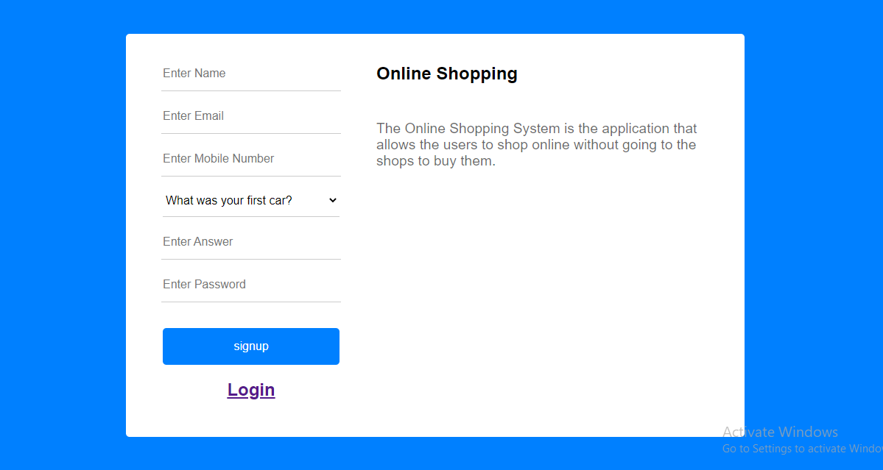

Login Page-

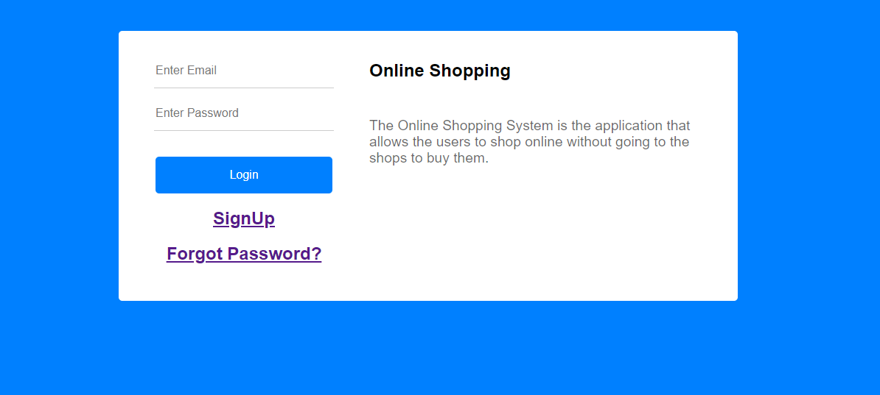

**Users**

Home Page-

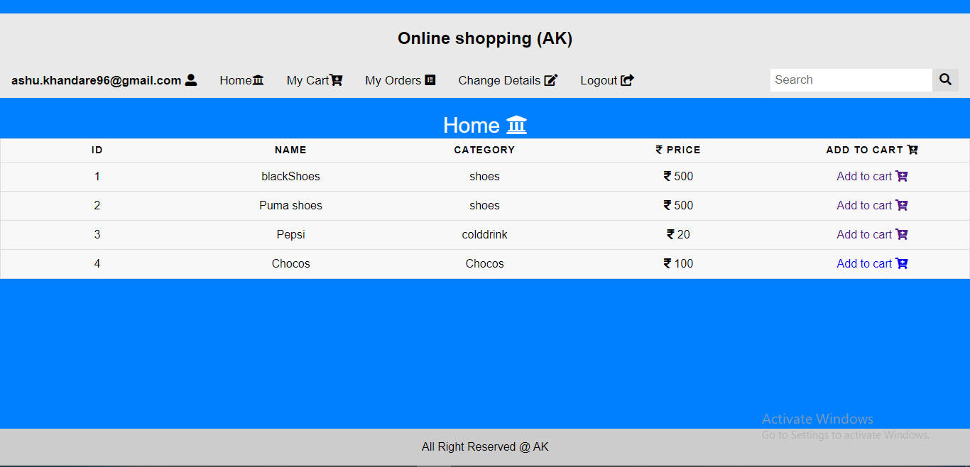

My Cart-

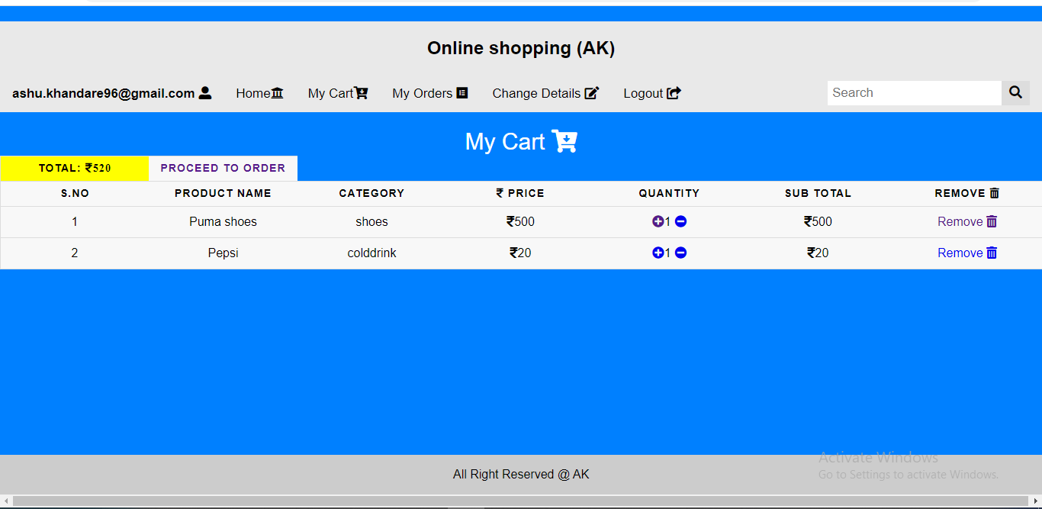

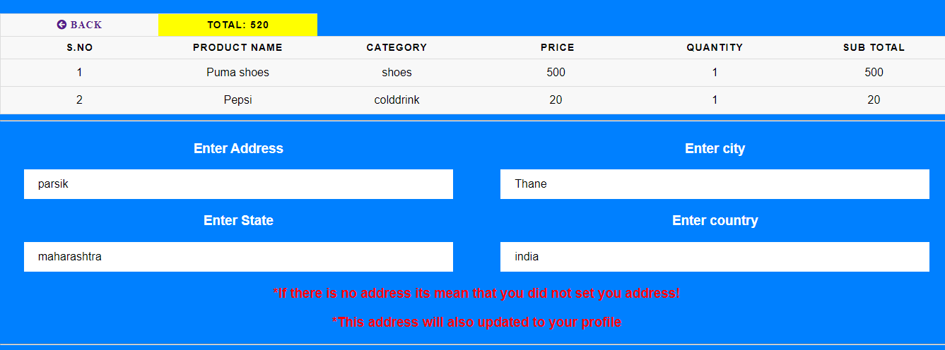

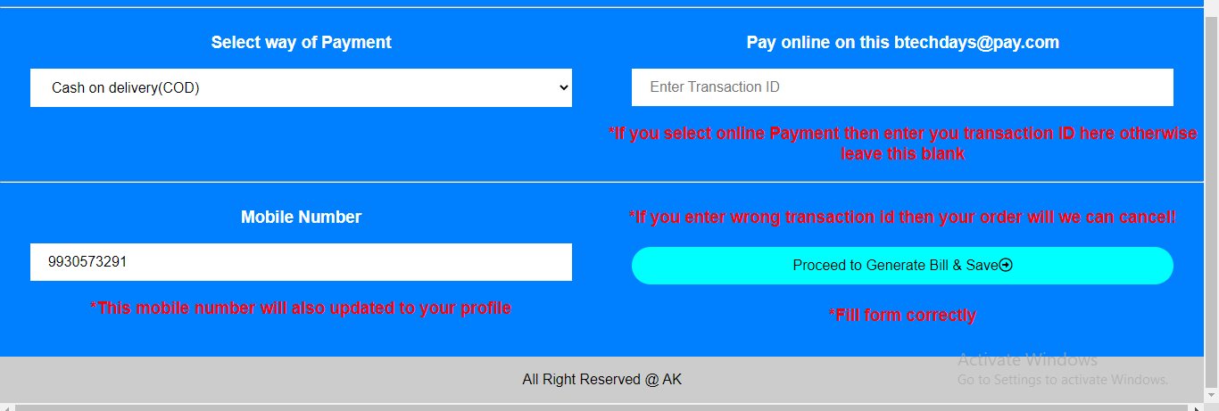

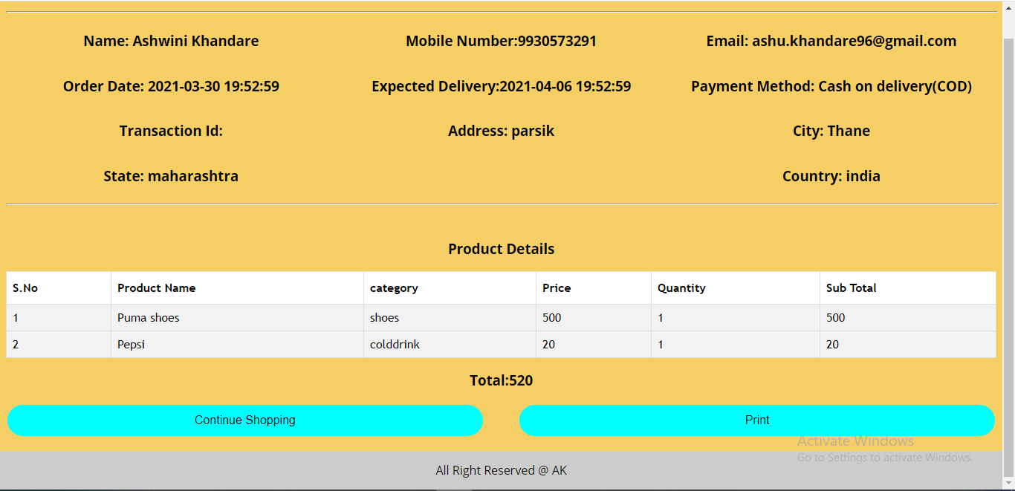

My Orders-

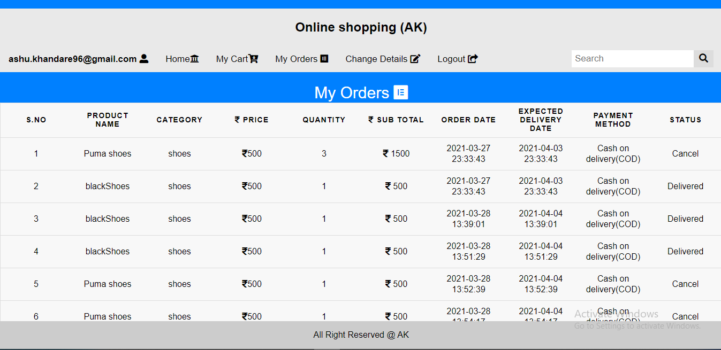

Change Details-

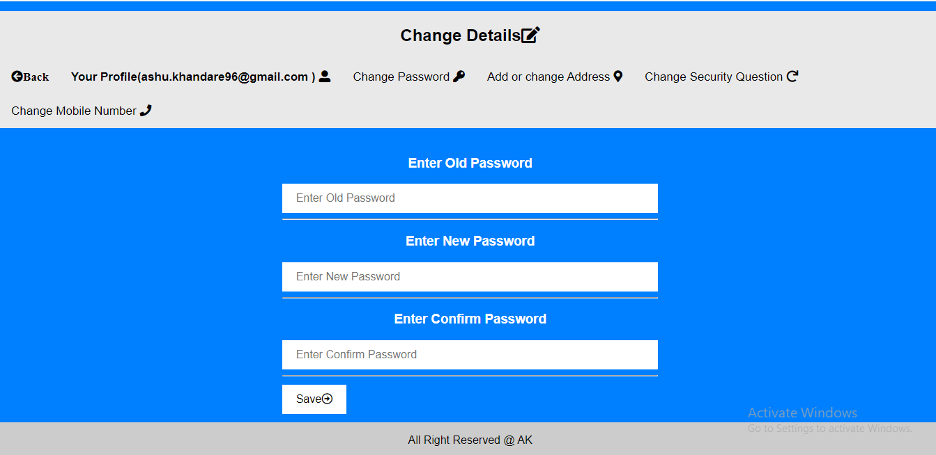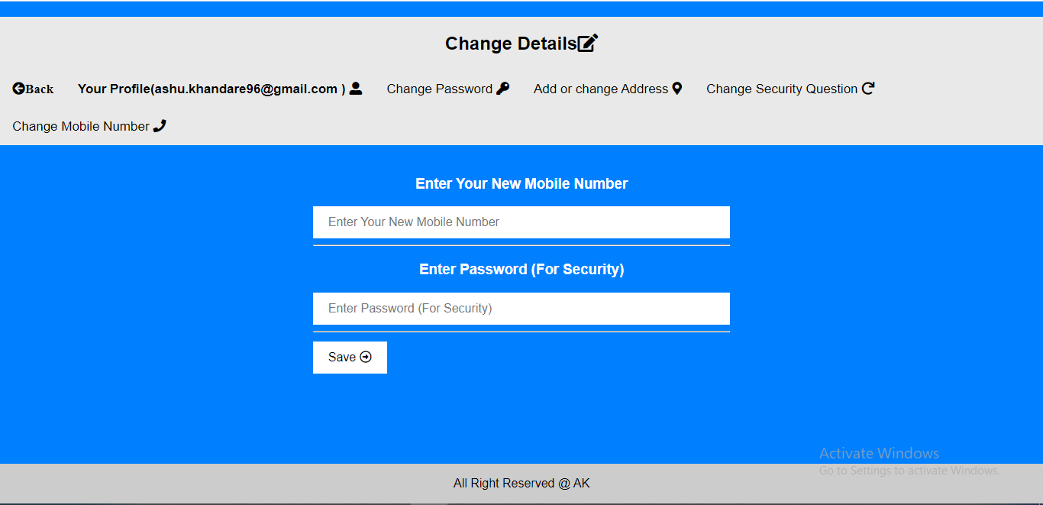

**Admin**

Add New Product-

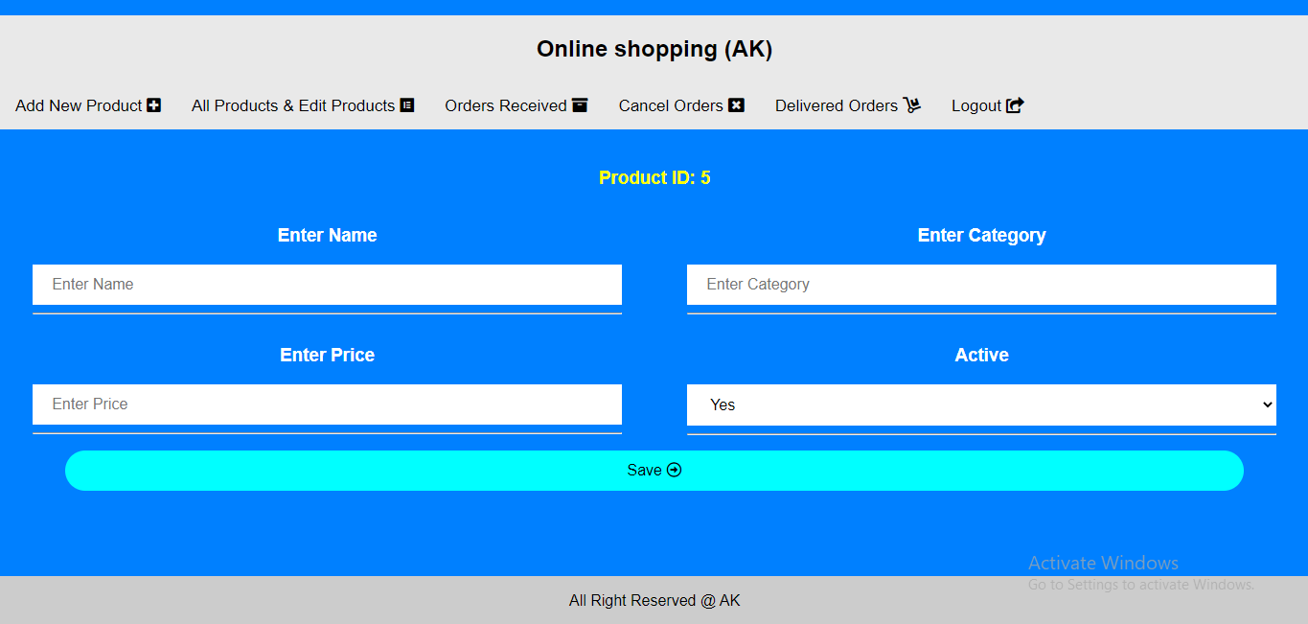

All Product And Edit Product-

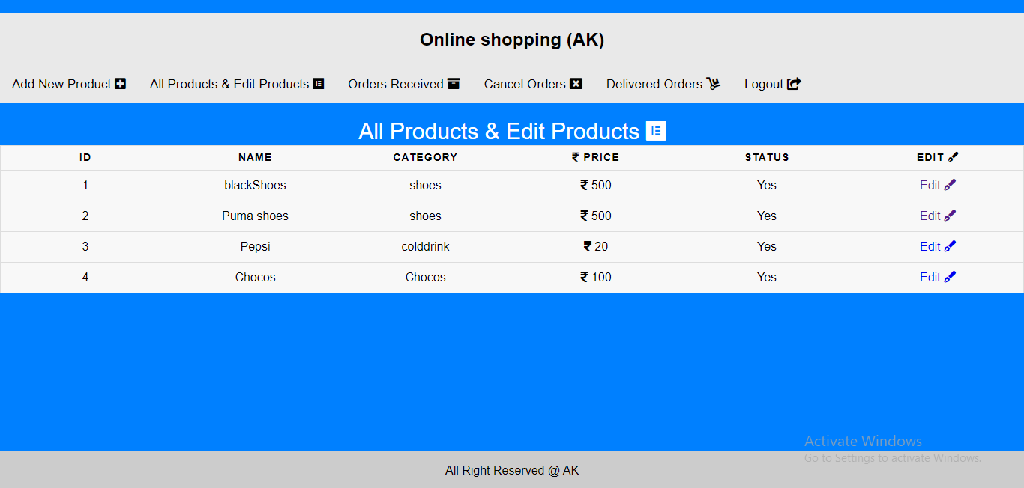

Orders Received-

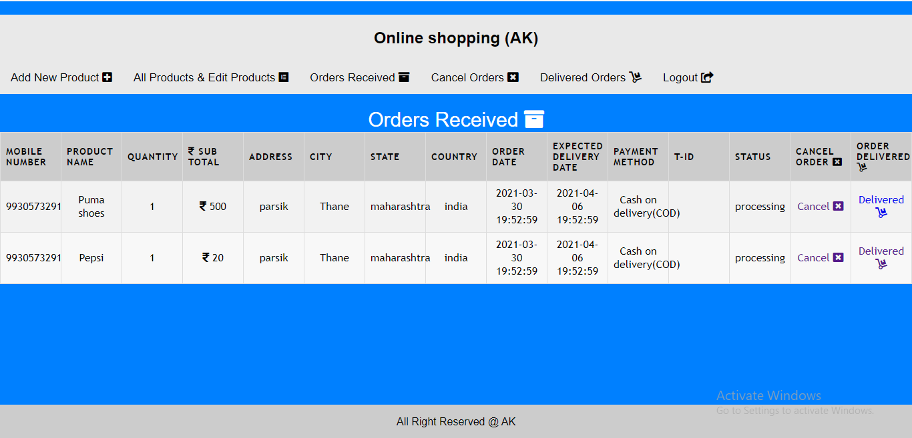

Cancel Orders –

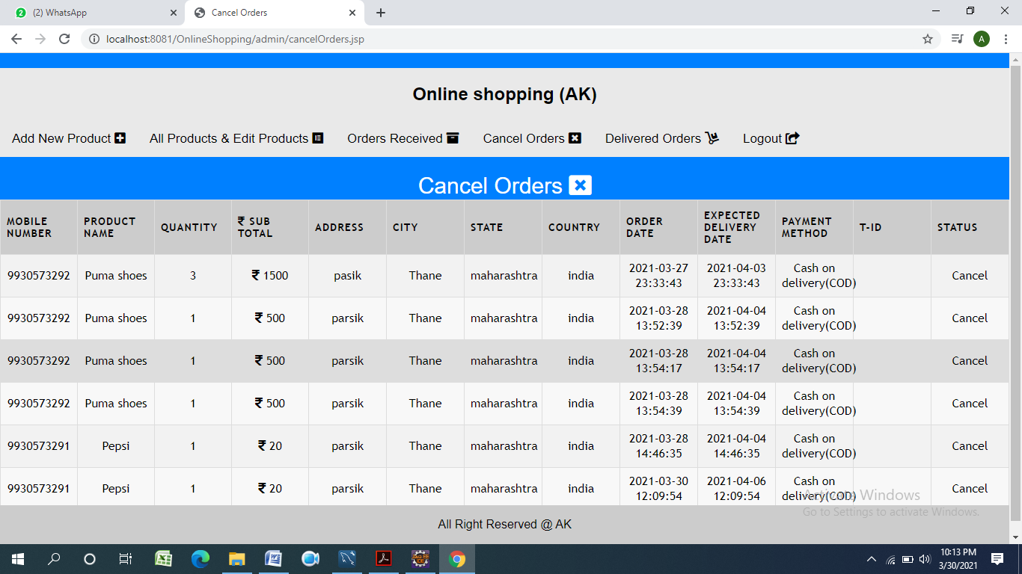

Delivered Orders –

